**If I met Lionel Messi, I would ask him...**

3 questions with an auxiliary

1. **How do you prepare for an important match?**
2. **What does football mean to you?**
3. **How do you handle pressure before important games?**

3 questions with ‘be’

1. **Who is the most difficult defender you have ever faced?**
2. **What is your favorite moment in your career?**
3. **Were you nervous before your first professional match?**

[Quizlet test](https://quizlet.com/792369963/test?answerTermSides=2&promptTermSides=6&questionCount=20&questionTypes=4&showImages=true)

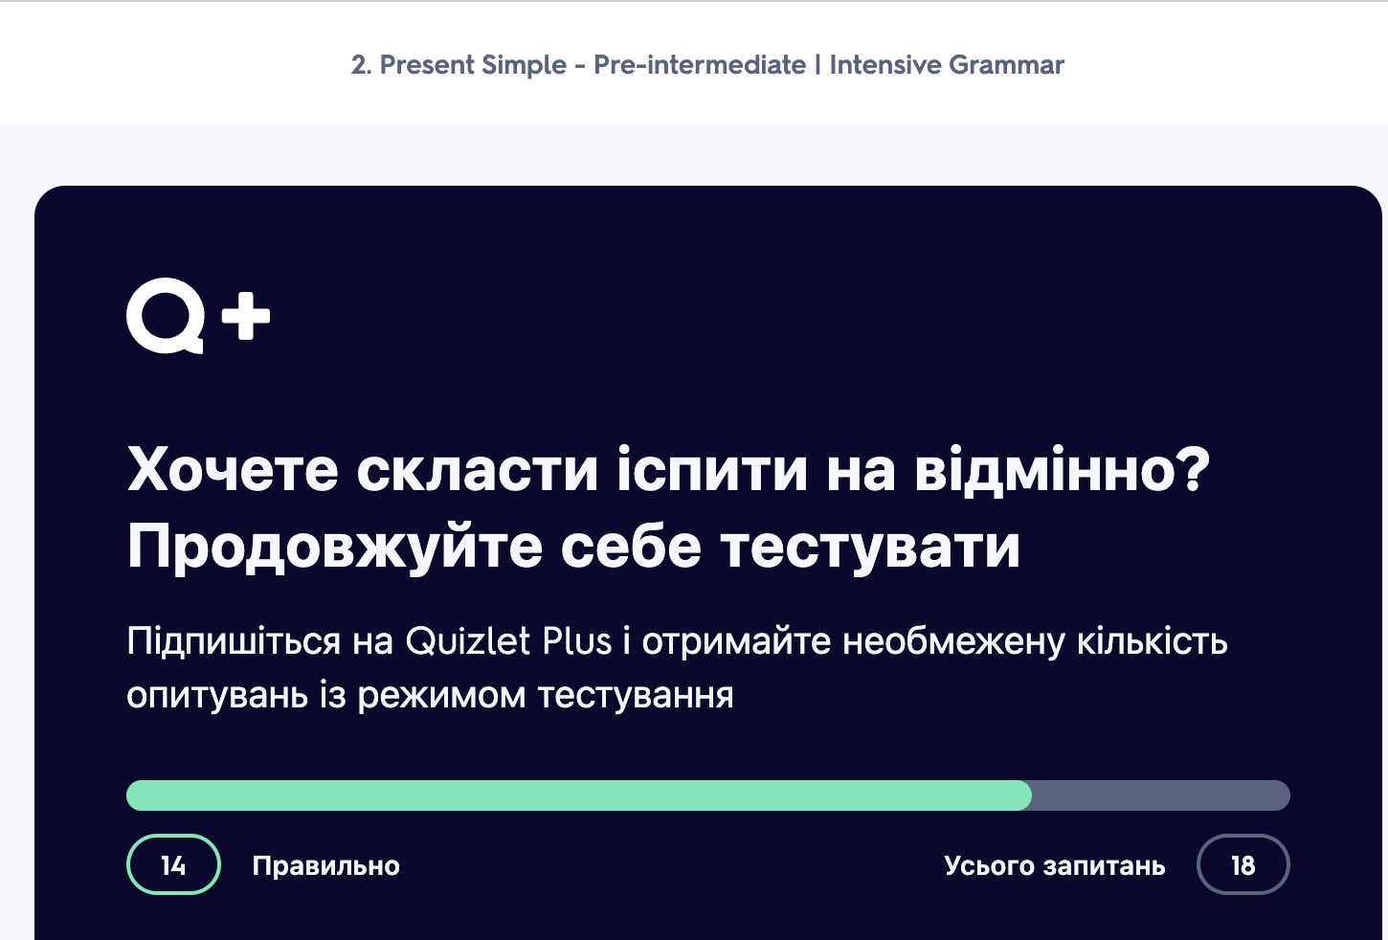

<https://test-english.com/grammar-points/a1/questions/>

